High/Low Level Design

* description/diagram of architecture chosen
  + Combination of monolithic and client/server
    - We will be using MySQL to store data so that’s why we would use client/server
    - Monolithic because our code will be in one place.
* class diagrams (UML), data flow diagram, activity diagram
  + **Data Flow diagram and Activity diagram at bottom of page.**
    - Classes: Store, Customer, Ingredients, Pizza, Pay
* database design
  + We will use MySql and we will use an xml file
  + **3NF design below**
* hardware your system will run on
  + C# Web App
* user interface
  + First Screen: Pizza Order Maker
  + Second Screen: Place Orders and added email
  + Third Screen: Input credit card information
  + Fourth Screen: Confirm order
* security (example, how login/system access will work)
  + Confirming the first 4 numbers of a credit card
  + Confirming email format
* Reports
  + We would keep track of reports in an excel spreadsheet
  + By us keeping track of certain items it will allow us to know what we need to order more of in the upcoming weeks for the business
    - How many pizzas were ordered in a week
    - What toppings were ordered
    - What sauces were ordered
    - What type of crust is ordered
* other outputs (email notifications?)
  + On your screen with the app it will say order confirmed
  + Pop ups to show if an item is not available

Activity Diagram:

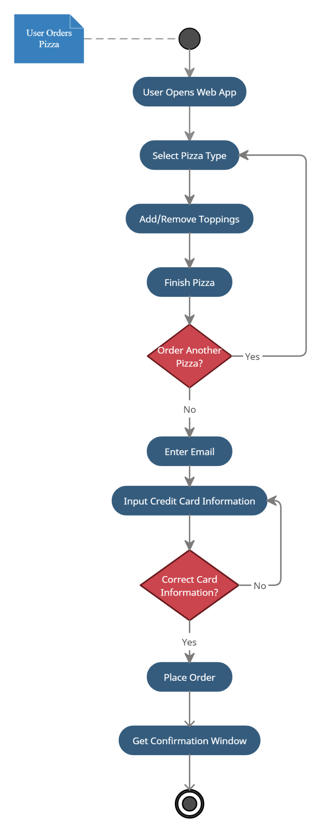

Data Flow diagram:

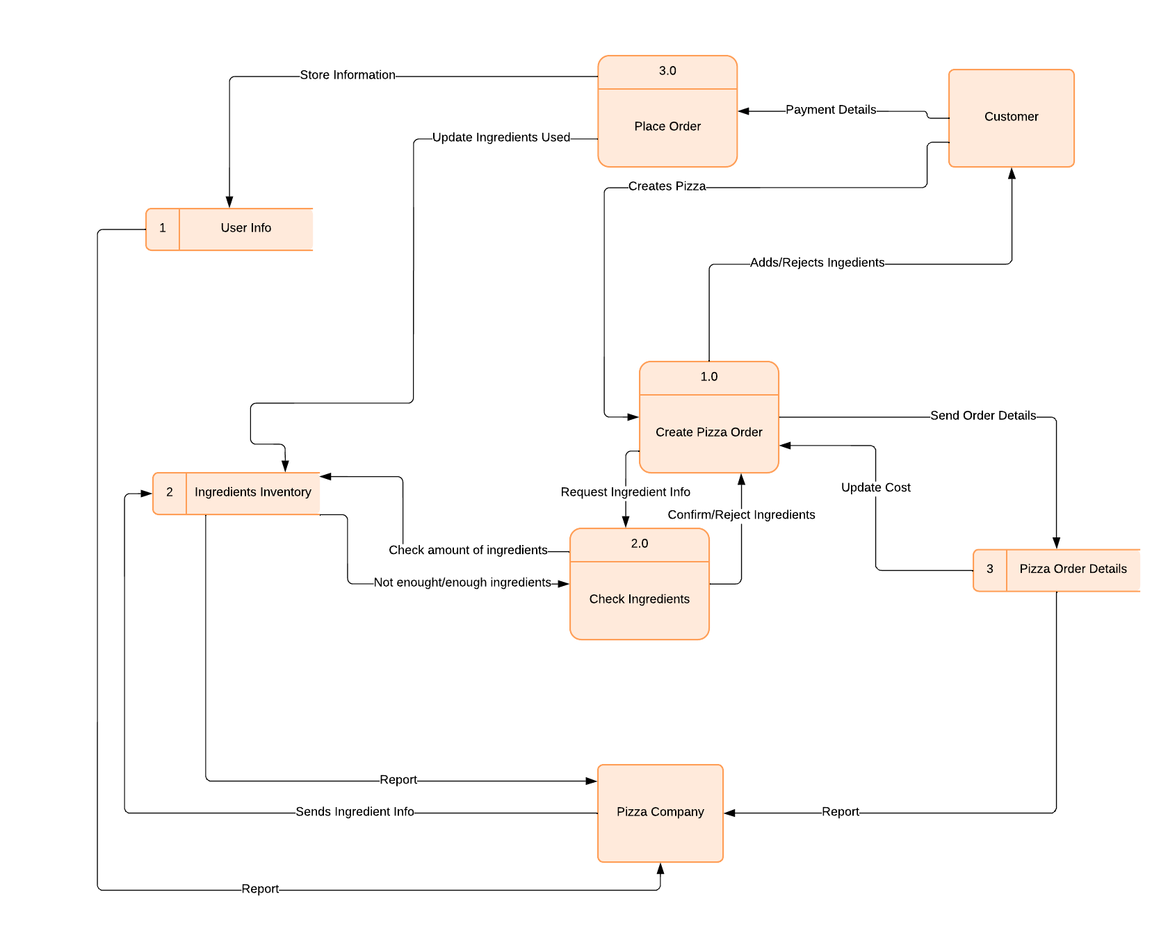

Class Diagram:

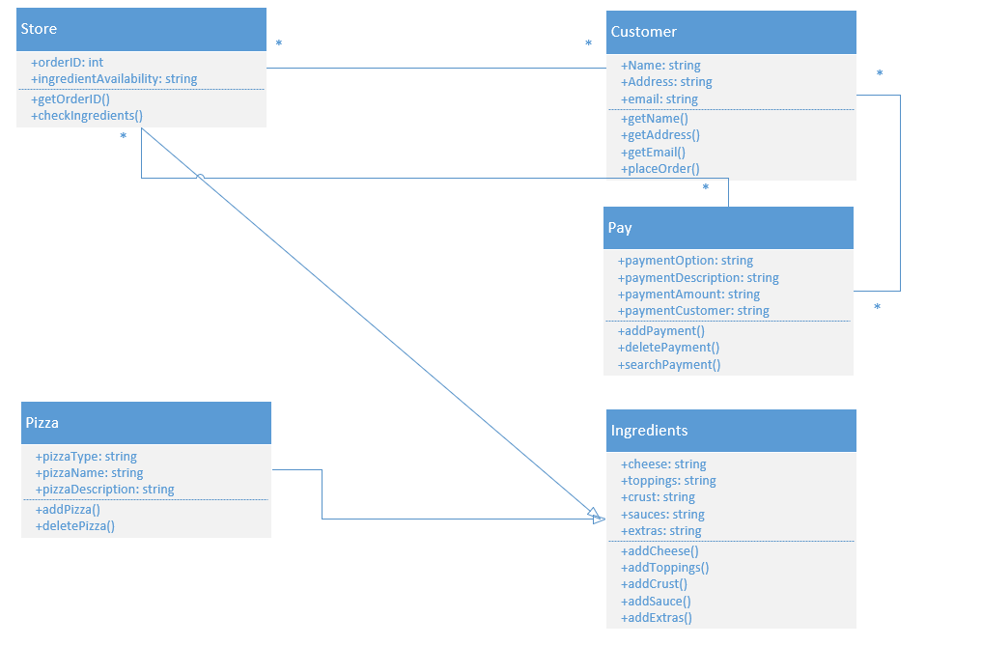

3NF Diagram:

